

**Post NAO Interaction Questionnaire**

**Age: Gender: User Number:**

1. How would you rate your level of experience with robots (circle one)?
   * No Experience
   * Beginner (have seen real robots or watched shows with physical robot characters)
   * Intermediate (have worked with commercial robots before)
   * Advanced (have worked on hardware or software development aspects of robots)
2. Which of the bellow images best describes your overall level of Valence during the interaction (circle one)? Valance is a measure of your overall positive or negative feelings.

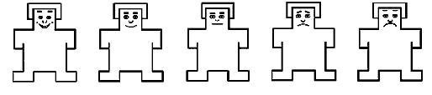

1. Which of the bellow images best describes your overall level of Arousal during the interaction (circle one)? Arousal is measure of your overall alertness.

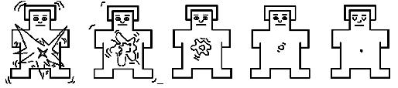

1. Circle a number for each statement indicating how much you agree or disagree with each.

|  |  |  |  |  |  |  |
| --- | --- | --- | --- | --- | --- | --- |
| # | **Statement** | **Strongly disagree** | **Somewhat disagree** | **Neutral** | **Somewhat agree** | **Strongly agree** |
| 1 | I feel that I understood the emotions the NAO displayed. | 1 | 2 | 3 | 4 | 5 |
| 2 | I found the emotions the NAO displayed throughout the interaction to be appropriate. | 1 | 2 | 3 | 4 | 5 |
| 3 | I think that the NAO is useful as a diet and fitness companion. | 1 | 2 | 3 | 4 | 5 |
| 4 | I could clearly hear what the NAO was saying. | 1 | 2 | 3 | 4 | 5 |
| 5 | I found the NAO responded appropriately to my statements. | 1 | 2 | 3 | 4 | 5 |
| 6 | It felt like the NAO is looking at me during the interaction. | 1 | 2 | 3 | 4 | 5 |
| 7 | I had a pleasurable experience interacting with the NAO. | 1 | 2 | 3 | 4 | 5 |
| 8 | I would use the NAO again as a diet and fitness companion | 1 | 2 | 3 | 4 | 5 |

1. Rank the following NAO features in terms of their ability to convey the robot’s emotion (1 being the best at conveying emotion, and 3 being the worst).
   * Eye colour
   * Body Poses
   * Voice Intonation
2. What about the NAO do you think could be improved?
3. What did you like the most about the NAO or the interaction?
4. What did you like the least about the NAO or the interaction?